# DUE DATE: 18.03.2024

Software Engineering - CEN 302

# Phase II: User Requirements and Application Specifications

**TEAM MEMBERS**

1. ALDO DACI [LEADER] - GitHub Username [AldoDaci]
2. KLAJDI KASTRATI [MEMBER] - GitHub Username [KlajdiKastrati]
3. SIDITA DUSHAJ [MEMBER] - GitHub Username [Siditadushaj21]
4. ANDREA KASA [MEMBER] - GitHub Username [andreakasa]

**OUR GITHUB REPOSITORY LINK:** [**https://github.com/AldoDaci/SE_Project_Phase1_Team_BarberScheduling**](https://github.com/AldoDaci/SE_Project_Phase1_Team_BarberScheduling)

# CHOSEN DEVELOPMENT MODEL

We chose the Waterfall model for our barbers scheduling and products shop project because it follows a step-by-step approach. This means we finish one phase before moving on to the next, which suits our project's needs. It helps us plan and manage the project better because we can predict what will happen and when. The model has clear stages like gathering requirements, designing, building, testing, and maintaining the project. Since we've already figured out what we need in the first phase, Waterfall works well for us because it doesn't expect big changes once we start. So, for our project, the Barber scheduling website, Waterfall is the right choice because it fits our requirements and helps us stay organized.

# USER REQUIREMENTS

# 1. End-users:

# - Roles: End-users encompass administrators, barbers, and receptionists involved in managing schedules and appointments.

# - Interests: They seek a user-friendly interface to simplify tasks like appointment management, customer record-keeping, and financial transactions. They desire features such as easy access to relevant functions, simple navigation, and intuitive workflows to enhance efficiency.

# 2. Clients:

# - Roles: The management team of the barbershop acts as the client, driving the project's initiation and benefiting from its successful implementation.

# - Interests: Clients aim to enhance accuracy and efficiency in scheduling and financial transactions. They seek a centralized system to streamline administrative tasks, ultimately contributing to the profitability and growth of the barbershop.

# 3. Developers:

# - Roles: Developers include software engineers and programmers responsible for designing, implementing, and maintaining the scheduling website.

# - Interests: They prioritize understanding end-user and client requirements to design and implement a suitable system. Technical aspects such as system architecture, database design, and user interface are their focus to ensure reliability, security, and scalability.

# 4. Regulatory Authorities:

# -Roles: Regulatory authorities oversee adherence to data privacy regulations and industry standards.

# - Interests: Their main concern is ensuring compliance with legal standards, particularly regarding financial data security and personal information protection. Compliance mitigates legal risks and fosters stakeholder trust.

# 5. Suppliers:

# - Roles: Suppliers in the barbershop's supply chain are integral to its operations.

# - Interests: An effective scheduling system can improve supply chain visibility, optimize inventory levels, and enhance collaboration between the barbershop and suppliers. Aligning project requirements with supplier needs can boost collaboration and overall supply chain performance.

# USER STORIES:

*Present a few detailed user stories. Include the user type (e.g.,* ***administrator, end-user****).*

*Clearly outline the corresponding requirement and the benefit it brings to the user or project.*

User Story - Barber

Requirement: As a barber, I need a feature to view my daily appointment schedule, including details such as appointment time, customer name, and requested service.

Benefit: This functionality allows barbers to effectively manage their daily schedules by providing them with clear visibility of upcoming appointments. It ensures that barbers can stay organized and prepared for each appointment, leading to smoother operations and improved customer satisfaction. Additionally, it helps barbers optimize their time by efficiently allocating slots for appointments, maximizing their productivity throughout the day.

# User Story - Receptionist

# Requirement:As a receptionist at the barbershop, I need a feature to manage inventory levels, including the ability to track product quantities, receive new shipments, and update stock availability.

# Benefit: This functionality enables receptionists to efficiently oversee inventory management within the barbershop. By providing tools to track product quantities, receive new shipments, and update stock availability, receptionists can ensure that the shop always has the necessary products in stock to meet customer demand. This helps prevent stockouts and delays in service delivery, leading to improved customer satisfaction. Additionally, it allows receptionists to optimize inventory levels, minimize excess stock, and reduce inventory holding costs, ultimately contributing to the shop's profitability.

# FUNCTIONAL REQUIREMENTS

* 1. **BRIEF DESCRIPTION**

*Write a short and clear sentence for each thing your system should do. Pretend you're explaining it to a friend who doesn't know much about computers.*

**1. User Authentication:** Enable secure login for users through username and password verification.

**2. User Registration:** Allow new users to register within the system by providing required information.

**3. Inventory Management:** Provide users with the capability to add, remove, and search for products in the inventory.

**4. Receipt Generation:** Allow users to create transaction receipts with necessary details included.

**5. Role-Based Access Control:** Implement access control based on user roles to restrict access to specific functionalities.

**6. Dashboard:** Offer users a centralized dashboard presenting an overview of relevant functionalities and data.

# ACCEPTANCE CRITERIA

*Make a simple checklist for each thing. What specific things must happen so you can say, "Yep, this part is finished!"? Imagine you're making a to-do list for each feature.*

**1. User Authentication:**

- The login page includes fields for entering a username and password.

- Upon successful login, users are redirected to the system's dashboard.

- Incorrect login attempts prompt appropriate error messages for user feedback.

**2. User Registration:**

- The registration form requires essential information like name, email, and password.

- Upon submission, the system creates and stores new user accounts in the database.

- Validation checks ensure uniqueness of usernames and email addresses during **registration.**

**3. Inventory Management:**

- Users can add new products by inputting details such as name and quantity.

- The delete function removes selected products from the inventory.

- Search functionality enables users to locate products by name or ID.

**4. Receipt Generation:**

- Users can generate transaction receipts by selecting purchased items and entering transaction details.

- Receipts include crucial information such as receipt number, product details, total cost, and payment specifics.

- Generated receipts are saved and accessible for future reference.

**5. Role-Based Access Control:**

- Different user roles (administrators, economists, workers) are assigned specific access privileges.

- Access control mechanisms are implemented system-wide to prevent unauthorized actions by users.

**6. Dashboard:**

- The dashboard grants users swift access to key functionalities like inventory management and receipt generation.

- Essential data and statistics are presented in an easily understandable format for user convenien

# 4. NON-FUNCTIONAL REQUIREMENTS a. BRIEF DESCRIPTION

*Describe how well your whole system should work. Is it about being fast, easy to use, or something else? Use simple words to explain each idea.*

**1. Compatibility:**

- The system should be compatible with various devices and web browsers to ensure accessibility for all users.

**2. Usability:**

- The system should offer an intuitive and user-friendly interface, requiring minimal training for end-users to efficiently complete tasks.

**3. Security:**

- Robust security measures must safeguard sensitive data, preventing unauthorized access or breaches.

**4. Reliability:**

- The system must consistently operate without frequent failures or downtime, ensuring uninterrupted access to critical functions.

**5. Performance:**

- The system must promptly respond to user inputs and maintain responsiveness, even during peak usage times.

**6. Maintainability:**

- The system should be easy to maintain and update, with clear documentation and a modular architecture supporting future enhancements and bug fixes.

**7. Scalability:**

- The system should accommodate increased workload and user traffic without significant performance or functionality degradation.

# b. ACCEPTANCE CRITERIA

**1. Performance:**

- Goal: Pages should load within 2 seconds on average, ensuring swift access to information.

- User interactions should have a response time of less than 0.5 seconds, providing a seamless and efficient user experience.

**2.** **Usability:**

- Goal: The system should offer intuitive navigation with easily recognizable menus and buttons, fostering user friendliness.

- Users should be able to complete common tasks within 2-3 clicks from the dashboard, simplifying their workflow and enhancing productivity.

**3. Reliability:**

- Goal: The system should maintain an uptime of at least 99.9%, ensuring continuous availability for users.

- Failures or errors should be minimized to occur less than once per week, with swift resolution by the technical team to ensure uninterrupted service.

**4.** **Security:**

- Goal: User authentication should employ robust encryption and secure protocols (e.g., HTTPS) to protect sensitive data.

- Access controls should be strictly enforced to restrict unauthorized access to data and functionalities, safeguarding system integrity.

**5. Scalability:**

- Goal: The system should gracefully handle a concurrent user load of at least 100 users without compromising performance.

- Database performance should scale proportionally with an increase in data volume, ensuring consistent system responsiveness as data grows

# 5. APPLICATION SPECIFICATIONS a. ARCHITECTURE

*Provide an overview of the chosen architecture:*

***Include high-level diagrams*** *or descriptions of system components and their interactions.*

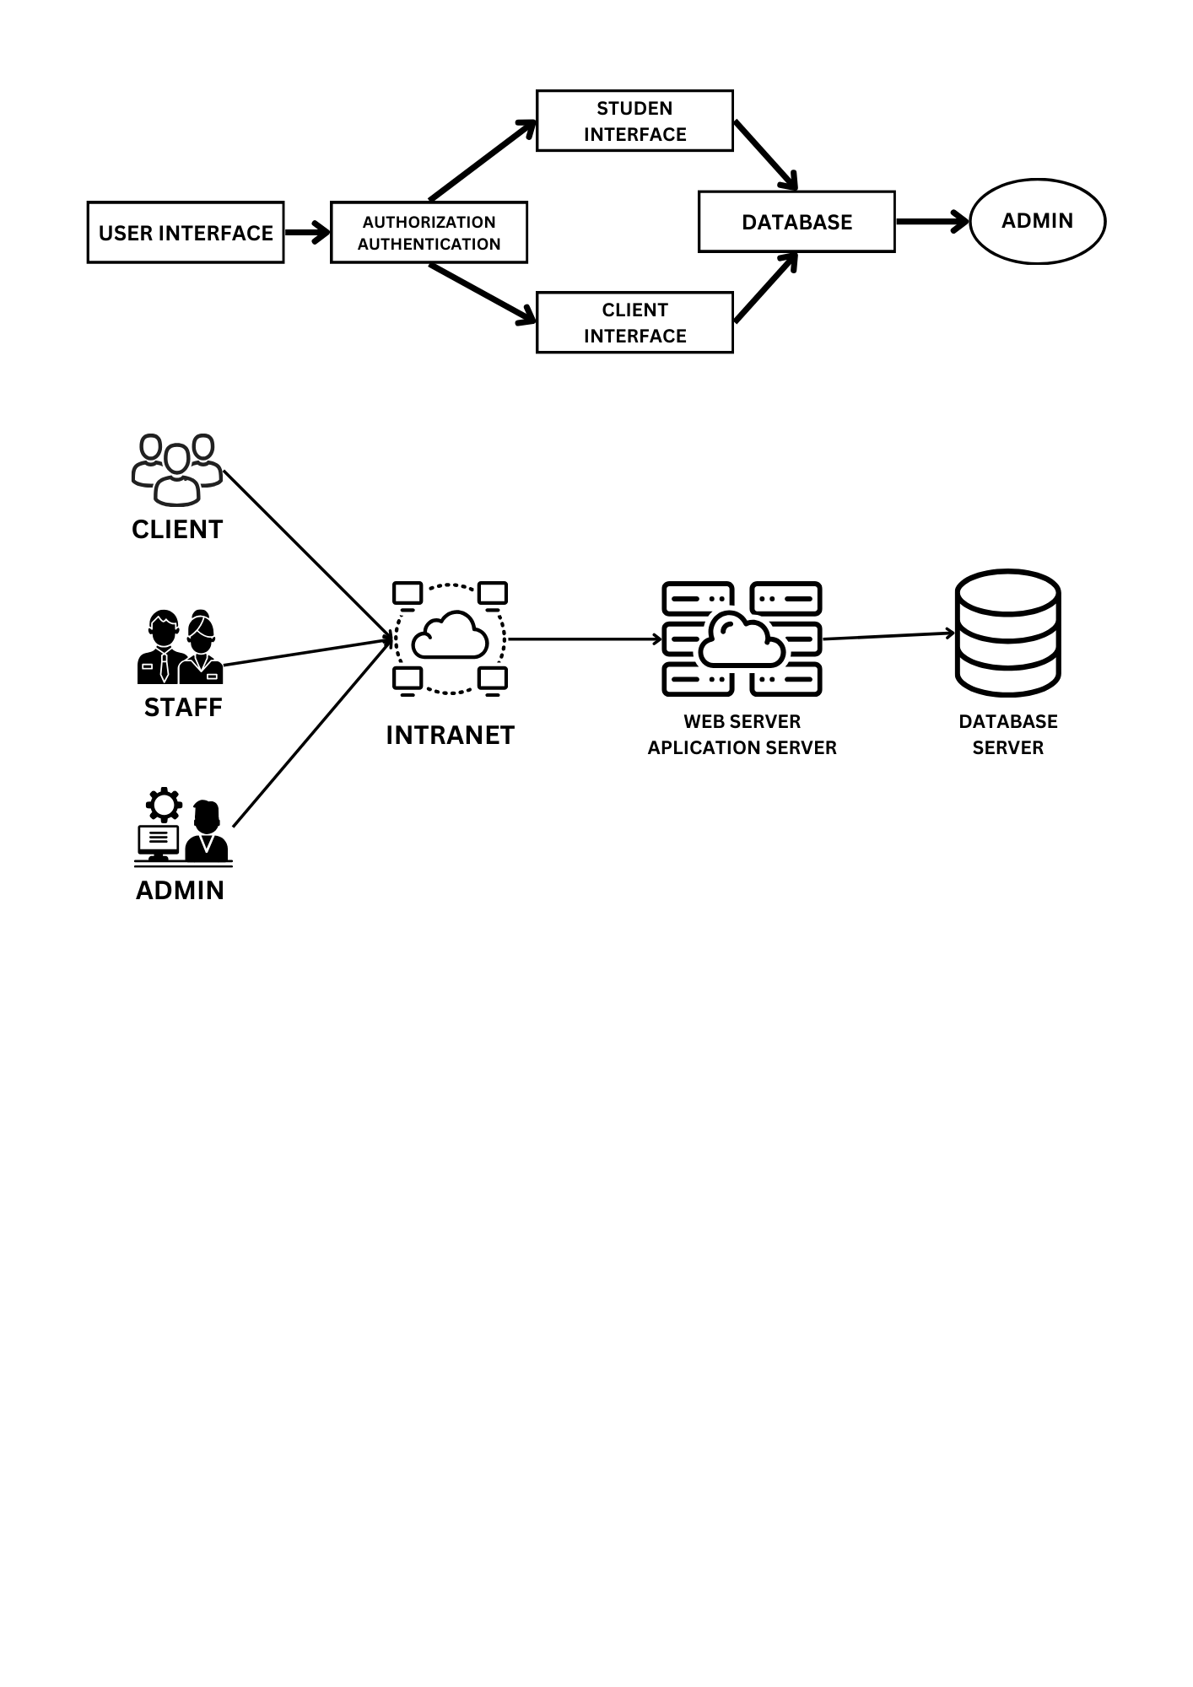

# DATABASE MODEL

*Detail the database model. Include information on tables, relationships, constraints, and any other relevant d*

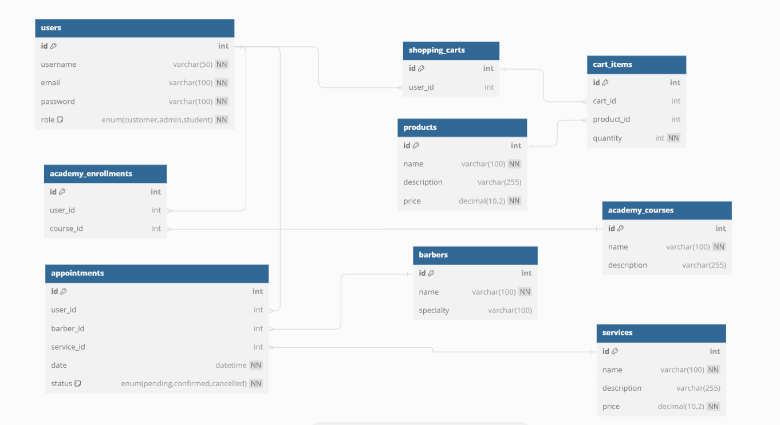

# TECHNOLOGIES USED

*List and briefly explain the technologies, frameworks, and languages chosen for development: Include any reasoning behind the choices, such as scalability or compatibility.*

**1. Java Programming Language:**

Java is chosen for its versatility, robustness, and platform independence. It allows for the development of scalable and reliable web applications. Java's extensive libraries and frameworks support various functionalities required for the website, including server-side programming, database connectivity, and web application development. Additionally, Java's strong type system and mature ecosystem contribute to building maintainable and efficient code.

**2. CSS (Cascading Style Sheets):**

CSS is essential for styling web pages and creating visually appealing user interfaces. It allows for the separation of content and presentation, enabling easier maintenance and updates to the website's design. CSS frameworks like Bootstrap or Materialize can be utilized to streamline the development process and ensure responsiveness across different devices.

**3. PHP (Hypertext Preprocessor):**

PHP is a popular server-side scripting language, well-suited for web development tasks such as handling form submissions, interacting with databases, and generating dynamic content. It integrates seamlessly with HTML, making it easy to embed PHP code within web pages. PHP frameworks like Laravel or CodeIgniter can be used to facilitate rapid development, maintainability, and security of the website's backend logic.

**4. Visual Studio IDE:**

Visual Studio is a powerful integrated development environment (IDE) that supports various programming languages, including Java, PHP, and CSS. It provides a rich set of features for code editing, debugging, and project management, enhancing developer productivity and collaboration. Visual Studio's extensive ecosystem of extensions and integrations further expands its capabilities, making it a suitable choice for developing and maintaining complex web applications like your barber shop website. Additionally, Visual Studio's compatibility with different operating systems ensures flexibility and ease of use for developers working on diverse platforms.

# USER INTERFACE DESIGN

*Showcase wireframes, mockups, or describe the user interface. Provide a visual representation of how users will interact with the system.*

Certainly! Here's a description of wireframes for the user interface of a barber website:

**1. Homepage:**

The homepage will feature a visually appealing design with images showcasing the ambiance of the barber shop.It will include a prominent header with the barber shop's logo, navigation menu, and possibly a call-to-action button for booking appointments. Below the header, there will be sections highlighting services offered, special promotions, and customer testimonials. A footer section may include contact information, social media links, and additional navigation links.

**2. Appointment Booking Page:**

The appointment booking page will have a simple and intuitive layout, allowing users to easily schedule appointments online. It will feature input fields for selecting the desired service, preferred date, and time slot. Users may also have the option to choose their preferred barber if applicable. Upon submitting the booking request, users will receive a confirmation message and possibly an email confirmation with the appointment details.

**3.Gallery Page:**

The gallery page will showcase images of hairstyles, barber shop interiors, and satisfied customers. It will use a grid layout to display multiple images, with options for users to click on individual images to view them in full size. Users may have the option to filter images by category (e.g., haircuts, beard trims, salon interior).

**4.Services Page:**

The services page will provide detailed information about the services offered by the barber shop, including descriptions, pricing, and duration. It will use a structured layout with sections for different categories of services (e.g., haircuts, beard grooming, hot towel shaves). Users may have the option to click on individual services to view more details or book an appointment directly from the service description.

**5. Contact Page:**

The contact page will feature a contact form allowing users to send messages or inquiries to the barber shop. It will also include contact information such as phone number, email address, and physical address. Additionally, a map widget may be included to show the location of the barber shop for users who prefer to visit in person.

**6. Login Popup:**

The login popup will provide users with a convenient way to access their accounts without navigating away from the current page. It will be triggered by clicking on a "Login" or "Sign In" button prominently displayed on the website's header or navigation bar. The popup will feature input fields for entering a username or email and a password. Additionally, there will be an option for users to reset their password if they've forgotten it. Upon entering valid credentials and clicking the login button, users will be authenticated and the popup will close automatically, providing access to their respective dashboard or the academy page. Users who are not yet registered can navigate to a separate registration page by clicking on a "Register" or "Sign Up" link within the popup.

**7. Dashboard Page:**

The dashboard page will serve as a central hub for both customers and barbers, providing essential information and functionalities. For customers, the dashboard may display upcoming appointments, reminders, and special promotions. Barbers may have access to tools for managing their schedules, tracking earnings, and communicating with clients. The dashboard will feature interactive widgets or cards with relevant information, such as appointment status, revenue summaries, and recent activity. Navigation menus or buttons will allow users to access different modules of the dashboard, such as appointment management, customer profiles, and performance analytics.

8. Academy Page:

The academy page will showcase a list of available courses offered by the barber shop's academy Each course will be presented as a card or tile, featuring the course title, brief description, and instructor's name. Users can browse through the list of courses and click on individual cards to view more details. The course details page will provide comprehensive information about the selected course, including syllabus, duration, schedule, and pricing.

Users interested in enrolling in a course can register directly from the course details page by filling out a registration form. The registration form will require users to provide their name, contact information, and preferred course start date.Upon successful registration, users will receive a confirmation message and possibly an email confirmation with further instructions on payment and course access.

# SECURITY MEASURES

*Briefly discuss the security measures and protocols implemented. Touch upon encryption, authentication, and any other security features.*

Certainly! Here's a rewritten discussion of security measures and protocols implemented for the barber website:

**1. User Authentication:**

- Users are required to authenticate themselves using a username/email and password before accessing the barber website's features.

- To enhance security, stringent password policies are enforced, mandating users to create strong passwords containing a mix of uppercase and lowercase letters, numbers, and special characters.

- User passwords are securely stored using industry-standard cryptographic hashing algorithms, safeguarding them against unauthorized access or data breaches.

**2. Access Control:**

- The barber website implements role-based access control (RBAC) to manage user access rights effectively.

- Access to various functionalities and data is restricted based on user roles (e.g., customers, barbers, administrators), ensuring that each user can only perform actions relevant to their role.

- By assigning specific permissions to each user role, the website maintains data confidentiality and integrity, protecting sensitive information from unauthorized access or modification.

**3. Data Encryption:**

- To protect data confidentiality during transmission, the barber website encrypts all communication between the client and server using secure communication protocols such as HTTPS (HTTP over SSL/TLS).

- Additionally, sensitive data stored in the website's database, such as user credentials, appointment details, and payment information, is encrypted using robust encryption algorithms.

- Data encryption measures ensure that even if unauthorized parties gain access to the data, they cannot decipher its contents without the appropriate decryption keys, thereby safeguarding user privacy and confidentiality.

**4. Session Security:**

- The barber website employs robust session management techniques to prevent session hijacking and unauthorized access.

- Each user session is assigned a unique session token generated using strong random number generators.

- Sessions are automatically terminated after a predefined period of inactivity or upon user logout, reducing the risk of unauthorized access to user accounts.

- By effectively managing sessions, the website mitigates the risk of session-related vulnerabilities and enhances overall security posture.